IDS Application Project

TO: Dr. Rolfe Sassenfeld

FROM: Caleb Carpenter <cmc007@nmsu.edu>; Lucio Rubio <junior_@nmsu.edu>; Isai Rocha <irocha4@nmsu.edu>; Ashley Godinez a77go33@nmsu.edu; Taylor Antonich <tganton@nmsu.edu>

DATE: September 29, 2021

SUBJECT: Defining the Project

The following will give an overview of our class project, a web-based IDS application. It will include the scope of items included in this project, our deliverables that we have deemed important, the details of our environment and a detailed methodology document.

This project will include a web-based IDS packet-filtering application.

The outcome of the project will be an AWS-hosted web-app that allows us upload a .pcap file to be analyzed under multiple different signature filters to determine whether signatures are present. The program will return whether or not signatures where detected, and in what lines they were found.

**Specific Scope and Deliverable Elements Will *Mostly Likely Include (but aren’t limited to):**

1. Web-based .pcap analysis program
2. Signature analysis and return (in the form of edited file, or browser pop-up)
3. User and Administrator access and login
   1. User access would include access to the program (and maybe a set of limited features).
   2. Administrator access would include access to all of the program, as well as the ability to make changes or adjustments to the filters and scope of the .pcap analysis (add new filters, save files, etc.).
4. Permanent user login (email-based), to remember .pcap file analysis history, saved filters, etc.

**\***Note: Scope and Deliverables will probably end up changing by the end of the project (if only a little bit).

**Other Elements to Be Included:**

1. Light-Dark Themes
2. User-return (GUI or file)
3. User-identity verification (probably via email)
4. Filter modification and saving
5. Permanent User Accounts (saving email/pass)
6. User/Admin login and access (how many features will each user be able to access)

The environment will include an AWS-hosted (cloud-based) web application.

The methodology will be a basic project flow document?

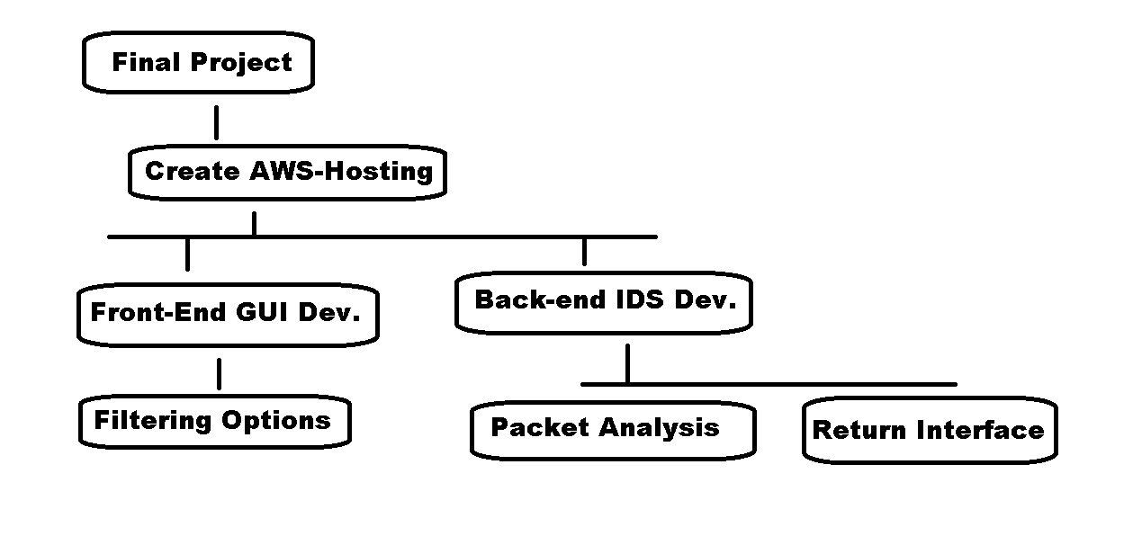

Figure 1 - Methodology Flow Chart